Symposium IoT

Hospitality solution: Phuket hotel

Cr. Chatpeth Kenanan

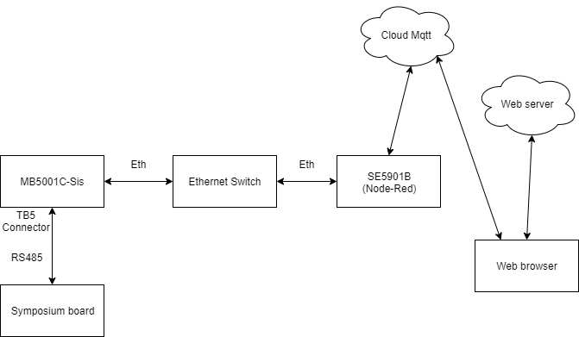

Fig. System blog diagram

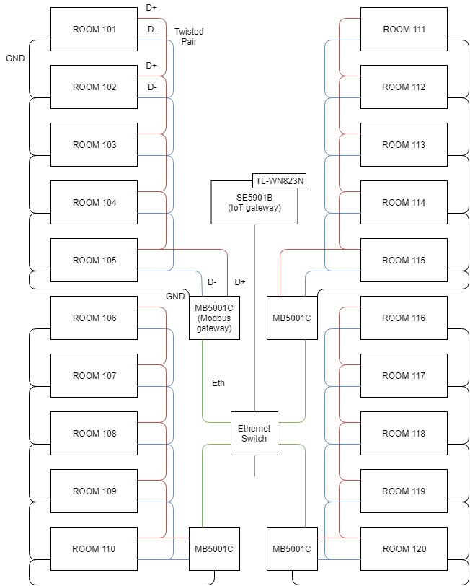

Fig. Installation

\

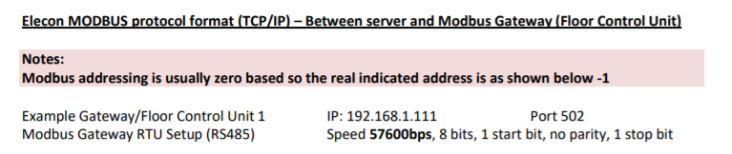

Fig. Modbus setting

# Software installation

## SE5901B

Before getting started with process below, contact Atop technical support team to make sure you have correct version of SE5901B-SDK Node-Red + Wi-Fi feature. User manual of the SE5901B-SDK are is SE5901B-SDK-Manual.pdf

### Upgrading SE5901B firmware

If your SE5901B not support WiFi feature, contact Jopson [jopsonli@atop.com.tw](mailto:jopsonli@atop.com.tw) to upgrade the firmware.

### Wi-Fi configuration

Put files from /sdk/src_files/se5901b/jffs2 into /jffs2 of the SE5901B. There are many way to transfer file into SE5901B. You can use ftp, tftp or other file transfer protocols. In this lesson we will use tftp protocols over tftpd32. Download tftpd32 from <https://tftpd32.jounin.net/>

Step1: Remote to SE5901B via SSH. Download SSH tools from <https://www.putty.org/>

Step2: Find the IP address of the SE5901B with Atop Utility. Download the Utility from <https://www.atoponline.com/wp-content/uploads/2017/11/Setup_MgmtUtility_V520_VCOM_V498.zip>

The default IP address is 10.0.50.100 25.255.0.0

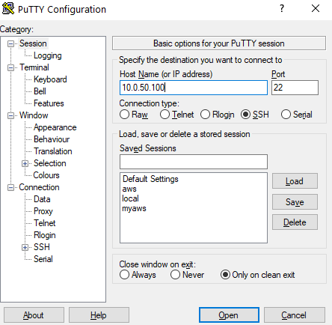

Step3: Username: admin, Password: default

Step4: Change permission to configuration files

$ chmod +x connectWifi <- Wi-Fi connection programs

$ chmod +x wificonfig <- Wi-Fi configuration

$ chmod +x user_post.sh <- Startup script

### Import Node-Red flow

Step1: Open web browser and direct to <ip address of the SE5901B>:1880

Step2: Import node-red flow from /sdk/src_files/flow_installed_phuket07302019.json and

data_log.json to Node-Red dashboard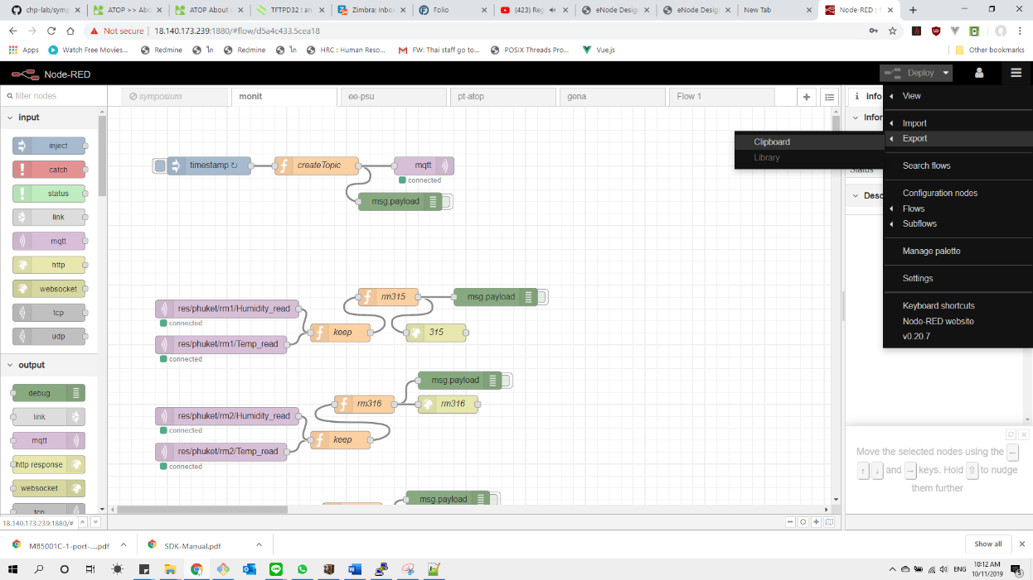

Step3: Setup mqtt security

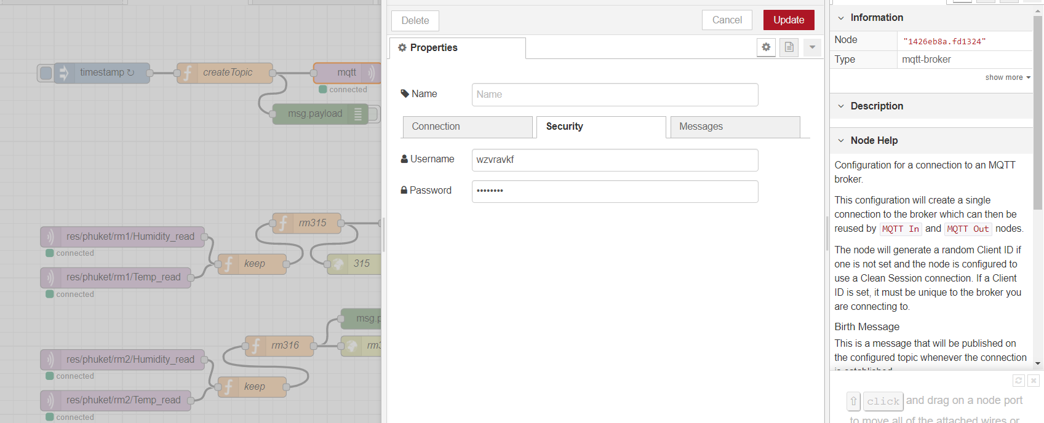

Step6: Change IP address of modbus polling node to MB5001C on each floor (Configuration guide of MB5001C are in next step)

Step7: Click on deploy node-red flow

## MB501C-Sis

### Configurations

User manual of MB5001C is MB5001C-1-port-Modbus-Gateway-User-ManualV1.1.pdf. The configuration step below are base on the User manual.

Step1: Connect your computer to the same network with The MB5001C over Ethernet cable, the default IP address of the MB5001C is 10.0.50.100 255.255.0.0

Step2: Open web browser and direct to <MB5001C IP address>

Step3: Log in with username: admin, password: default

Step4: Chane the configuration follow image below

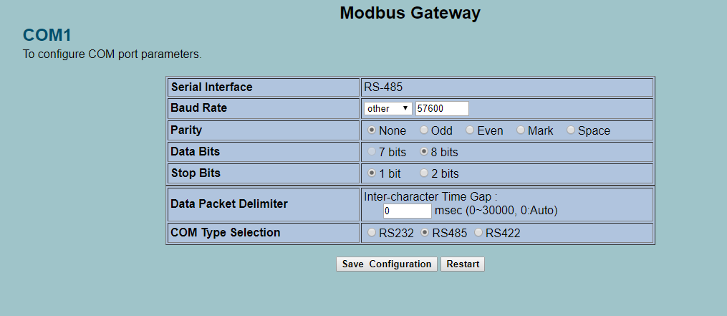

Step5: Change the IP address of the MB5001C to match with Node-Red setup on Import Node-Red flow section on lesson 1

Step6: Save the configuration.

Step7: Restart the device.

Step8: Use web browser, direct to the new IP address on Step5 to confirm the configuration are correct.

## Web server

### Installation

The current version of SympLab server are running on free server <https://www.heroku.com/>

If you need to continue develop on Heroku, I suggest to learn more about deploy Node.js application on Heroku from <https://devcenter.heroku.com/articles/getting-started-with-nodejs>

In case you have your own server. Upload Web Server source code from /sdk/src_files/web_server to the server.

On /sdk/src_files/web_server file descriptions are:

Server.js -> Node.js server entry point

jwt-vanilla.js -> Authentication lib

*.html -> Web page source code

/public -> related file for the web page which can access by public

/puket -> configuration web page of each rooms

To install the server on your own serve, follow step below:

Step1: Install node.js and npm, read more about node.js <https://nodejs.org/en/docs/>

$ sudo apt install nodejs

$ sudo apt install npm

Step2: Upload /web_server to the server.

### Run the server

To start the server

Step1: Enter the server source code directory. Then start the node.js server

$ cd ./web_server

$ sudo node server.js or

$ sudo node server.js & -> “&” mean run on the background

### Stop the server

$ sudo lsof -i:81

$ sudo kill <pid from result above>

## Data log

The current version of SympLab keep data about humidity, temperature on google sheet.

### Google sheet

Follow these steps to send data from Node-Red to google sheet.

1. Create new google form [https://docs.google.com](https://docs.google.com/)
2. Add new para meter

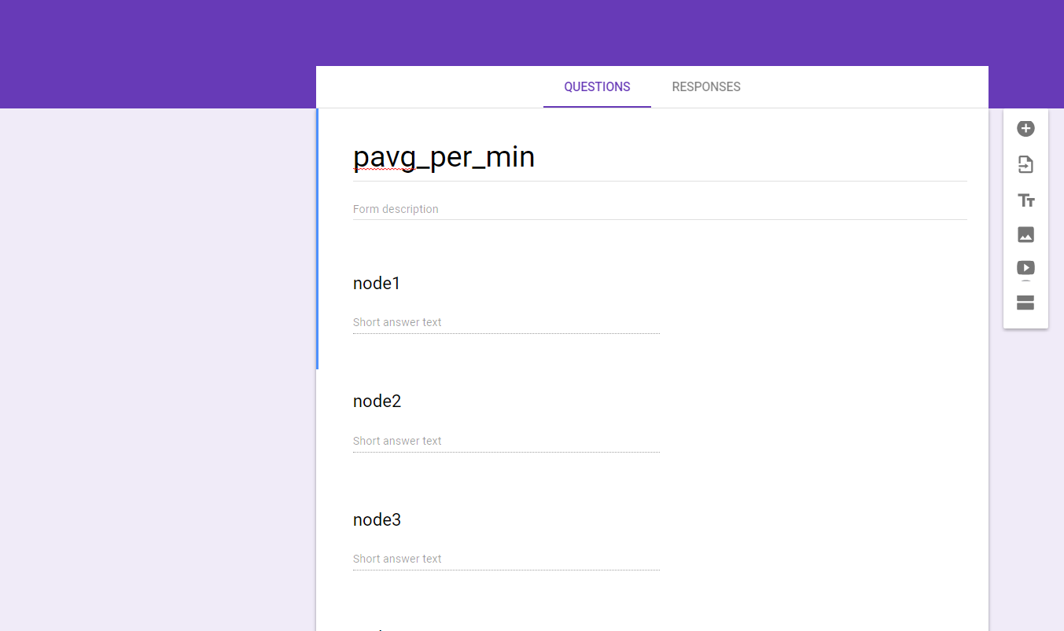

1. Connect google form with sheet

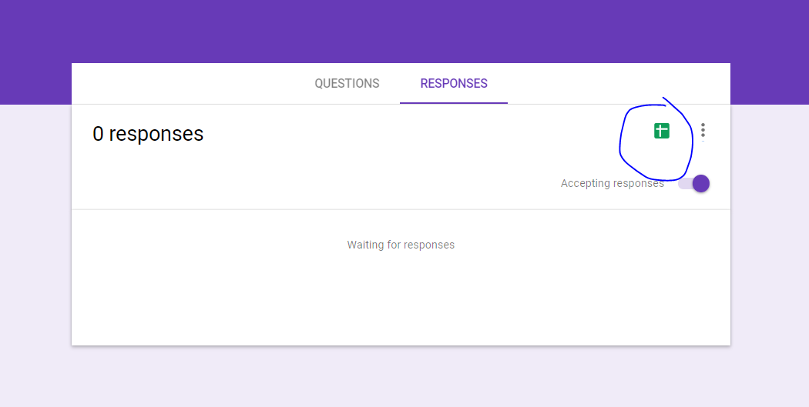

1. Get pre-filled link

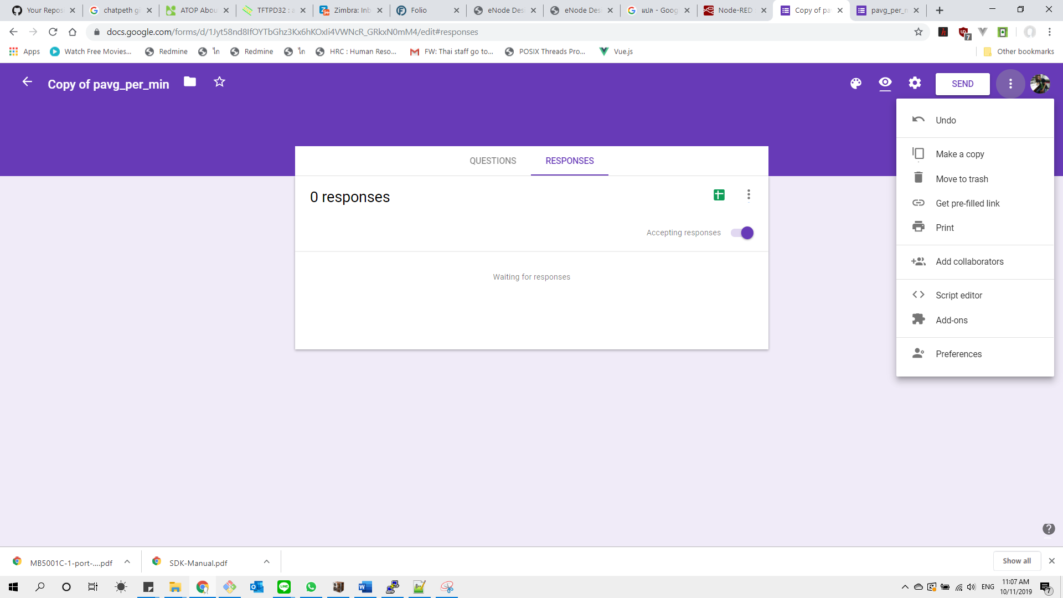

1. Sample pre filled link <https://docs.google.com/forms/d/e/1FAIpQLScHbZ_dwtgBm6wG1jLq_cKCqTTGvdpo3FYmsK2YCILTlTW26g/viewform?usp=pp_url&entry.1732737962=0&entry.1218485471=1&entry.339382278=2&entry.376692470=3&entry.687312231=4&entry.576090351=5&entry.509871658=6&entry.614956280=7&entry.1513347545=8&entry.1493512792=9>
2. Edit your pre-filled link to form look like [https://docs.google.com/forms/d/e/1FAIpQLSecWR67I_3LNaPj1DVDXePkYV-j9XHAMAWba4e8nf-r-aao1Q/formResponse?usp=pp_url&entry.1441242961={{payload.0}}&entry.355508118={{payload.1}}&entry.988660010={{payload.2}}&entry.2082851192={{payload.3}}](https://docs.google.com/forms/d/e/1FAIpQLSecWR67I_3LNaPj1DVDXePkYV-j9XHAMAWba4e8nf-r-aao1Q/formResponse?usp=pp_url&entry.1441242961=%7b%7bpayload.0%7d%7d&entry.355508118=%7b%7bpayload.1%7d%7d&entry.988660010=%7b%7bpayload.2%7d%7d&entry.2082851192=%7b%7bpayload.3%7d%7d)
3. Put link on step 6 to data logging node-red flow

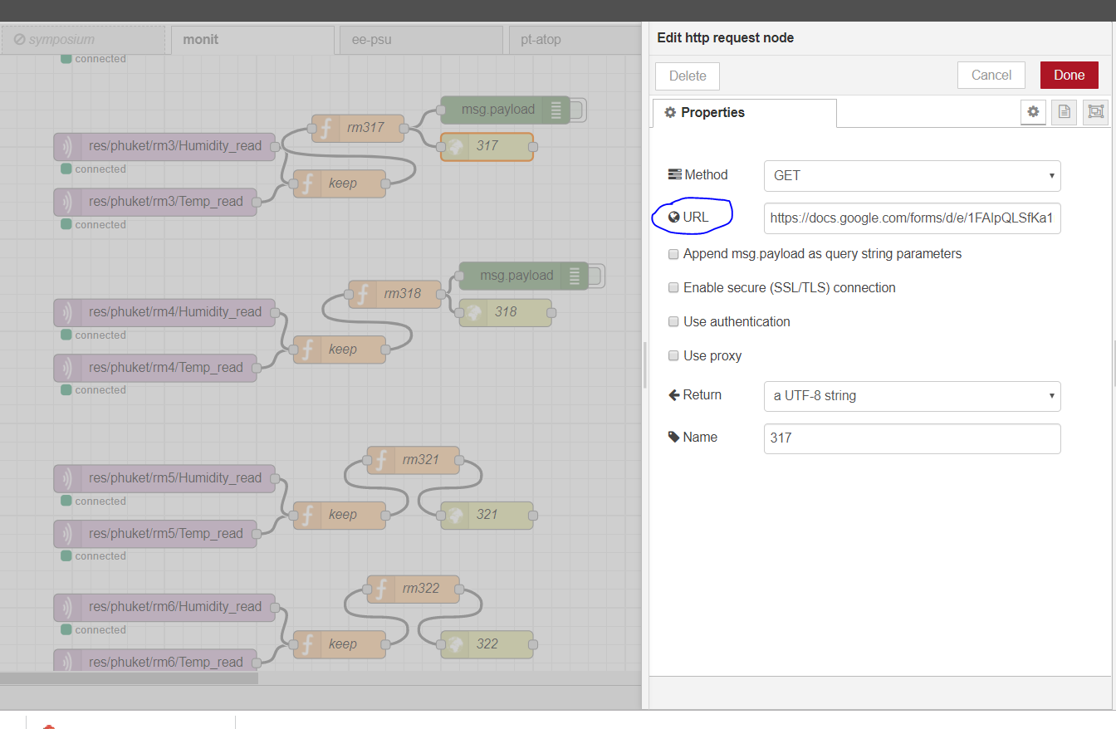

1. Reproduce step 1 – 7 with each room

### Auto save google sheet

1. Remove non-use cell

//Remove All Empty Columns in the Entire Workbook

function removeEmptyColumns() {

var ss = SpreadsheetApp.getActive();

var allsheets = ss.getSheets();

for (var s in allsheets){

var sheet=allsheets[s]

var maxColumns = sheet.getMaxColumns();

var lastColumn = sheet.getLastColumn();

if (maxColumns-lastColumn != 0){

sheet.deleteColumns(lastColumn+1, maxColumns-lastColumn);

}

}

}

//Remove All Empty Rows in the Entire Workbook

function removeEmptyRows() {

var ss = SpreadsheetApp.getActive();

var allsheets = ss.getSheets();

for (var s in allsheets){

var sheet=allsheets[s]

var maxRows = sheet.getMaxRows();

var lastRow = sheet.getLastRow();

if (maxRows-lastRow != 0){

sheet.deleteRows(lastRow+1, maxRows-lastRow);

}

}

}

Save and clear the sheet

function saveAsSpreadsheet(){

var sheet = SpreadsheetApp.getActiveSpreadsheet();

var range = sheet.getRange('Form Responses 1!A1:B3');

var now = new Date();

sheet.setNamedRange('buildingNameAddress', range);

var TestRange = sheet.getRangeByName('buildingNameAddress').getValues();

Logger.log(TestRange);

var destFolder = DriveApp.getFolderById("1K062Ec_Y1j5YlNYP1ZFdsiIq5kzNI2pw");

DriveApp.getFileById(sheet.getId()).makeCopy(now, destFolder);

deleteCell();

}

function deleteCell(){

var ss = SpreadsheetApp.getActive();

var allsheets = ss.getSheets();

for (var s in allsheets){

var sheet=allsheets[s]

var maxRows = sheet.getMaxRows();

if(maxRows > 1)

{

sheet.deleteRows(2, maxRows - 2);

}

}

}

function __deleteAllResp(){

var form = FormApp.openById("1fOhDnW5kXiUYjURMAWVW4wU5dsNF3UheJXGCd1WJkeQ");

form.deleteAllResponses();

}

## Mqtt

### Configurations

